Rafting Site – Planning Document

1. 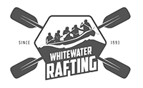
   * Primary – color: #33658A
   * Secondary - color: #78C0E0
   * Accent1 – color: #CAB6CD
   * Acent2 – color: #BA8F95
   * Heading-font: Poppins-thin
   * Text-font: Poppins-regular
2. https://coolors.co/33658a-78c0e0-cab6cd-ba8f95-b5bd89